Fish tactis (fishes)

Clown loach f1 price= 10

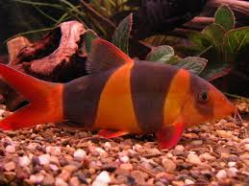

Bio.

* **Temperature:** They live well from about *75 to 80+ degrees F.*, but they're probably most comfortable at ***about 78 degrees F***.
* **Feeding: *Premium Fish Food Flakes*** when very small and small ***Premium Pellet Food*** when larger.
* **Life Span:***Clown Loaches* can live in ***excess of 20-years***, if they're fed premium food and kept in a very large aquarium with very fresh water.
* **Origin:** These Loaches are gotten in the wildernesses in Borneo and Sumatra, which are two vast islands in Southeast Asia, and they now live in aquariums all through the greater part of the world.
* **Behaviors:***Clown Loaches* are ***active swimmers*** and quarrel gently with each other but are***rarely aggressive***.
* They need a cave to hide in and spend a lot time hidden away to then come out and flash their beautiful colors and pattern. Sometimes they pile on top of each other or lie on their sides, pretending to look sick or dead.

**Blue Acara Cichlid f2price=17**

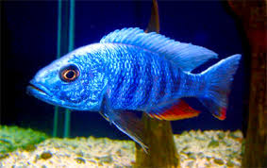

**Origin:** Metallic Blue Acaras are cross breeds of the Blue Acara and Electric Blue Ram, which are both Neotropical Cichlids from northern South America. In any case, now Metallic Blue Acaras live in aquariums everywhere throughout the world.

**Behaviors:** *Metallic Blue Acaras*are usually ***not too aggressive,*** but males are territorial, when they're preparing to breed, breeding, or protecting their eggs and babies. Male*Metallic Blue Acaras* often chase after other male *Metallic Blue Acaras* and make them miserable, so it's best to keep only one male in an aquarium, unless the aquarium is very big with lots of other fish and lots of hiding places.

**Life Span:** *Metallic Blue Acaras*can live for ***several years***. Keep the water conditions excellent and feed them premium foods, and they will most likely breed and produce the next generation of fish for your aquarium.

**Feeding:** ***Premium Fish Food Flakes and Pellets*** are best. Flakes and smaller sized pellets when they're small, and larger size pellets when they're bigger are the ideal foods for these fish

Blacktop corydoras f3 price=15

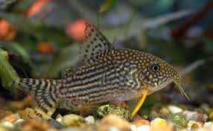

**Origin:** The progenitors of Corydoras Catfish lived in the Orinoco Rainforests in South America. Corys are diminutive person catfish and are brilliant pet fish that are presently discovered living in aquariums everywhere throughout the world. There are numerous species with an assortment of examples.

**Behaviors:** They like to swim across the bottom using the barbles around their mouths to find tidbits of food. Then they'll stop to relax for a while, but every once in a while they swim quickly up to the surface of the water for a gulp of air. Cory Catfish are not aggresssive to other fish.

**Feeding: *Premium Fish Food Flakes***.

**Life Span:** Cory Cats can live for ***a few years*** and maybe several years with excellent care. 

EMERALD GREEN cat fish f4 price=14

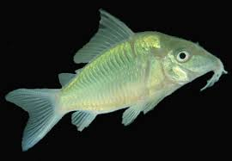

**Origin:** This catfish was gotten in Amazon Rainforest in South America. Emerald Green Catfish are protected diminutive person catfish and are brilliant pet fish that are presently discovered living in aquariums everywhere throughout the world.

**Behaviors:** They like to swim across the bottom using the barbels around their mouths to find tidbits of food. Then they'll stop to relax for a while, but every once in a while they swim quickly up to the surface of the water for a gulp of air. Emerald Green Catfish are not aggressive to other fish.

**Feeding: *Premium Fish Food Flakes***.

**Life Span:** this catfish can live for ***a few years***, maybe several years with excellent care, including excellent water and premium fish foods.

**Premium Pearlscale Koi Angelfish s1 price=18**

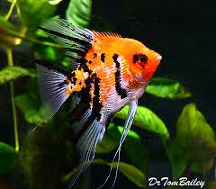

**Origin:** Heavenly attendants are extraordinarily molded fish, and presumably consequently a standout amongst the most famous aquarium fish. Their precursors initially lived in the heart of the Amazon Rainforest in South America.

**Behaviors:** Most Angels are not active swimmers. They seem to prefer a more ***relaxed lifestyle*** than many other hyper-active fish.

**Feeding: *Premium Fish Food Flakes*** when small and ***Premium Pellet Food*** when larger.

**Life Span:** Angels live for ***several years*** and sometimes many years with proper care, good water, and premium food.

**Assorted Blue Angelfish s2 price=20**

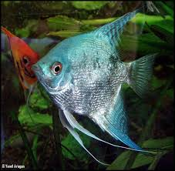

**Origin:** Heavenly attendants are extraordinarily molded fish, and presumably consequently a standout amongst the most famous aquarium fish. Their precursors initially lived in the heart of the Amazon Rainforest in South America.

**Feeding: *Premium Fish Food Flakes*** when small and ***Premium Pellet Food*** when larger.

**Life Span:** Angels live for ***several years*** and sometimes many years with proper care, good water, and premium food.

**Behaviors:** Most Angels are not active swimmers. They seem to prefer a more ***relaxed lifestyle*** than many other hyper-active fish. Angels are members of a big family of fish called Cichlids, and most Cichlids are aggressive, some are even very aggressive, but Angels are usually **not too aggressive**. Unless they are pairing off, spawning, or tending to their eggs or babies, then they are aggressive. A pair will work together to attack other fish that come too close.

**Marbled Blue Angelfish s3 price=13**

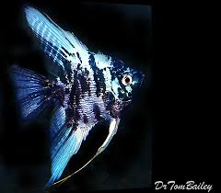

**Origin:** Heavenly attendants are extraordinarily molded fish, and presumably consequently a standout amongst the most famous aquarium fish. Their precursors initially lived in the heart of the Amazon Rainforest in South America.

**Behaviors:** Most Angels are not active swimmers. They seem to prefer a more ***relaxed lifestyle*** than many other hyper-active fish. Angels are members of a big family of fish called Cichlids, and most Cichlids are aggressive, some are even very aggressive, but Angels are usually **not too aggressive**. Unless they are pairing off, spawning, or tending to their eggs or babies, then they are aggressive. A pair will work together to attack other fish that come too close.

**Life Span:** Angels live for ***several years*** and sometimes many years with proper care, good water, and premium food.

**Feeding: *Premium Fish Food Flakes*** when small and ***Premium Pellet Food*** when large

**Albino Pearlscale Angelfish s4 price=16**

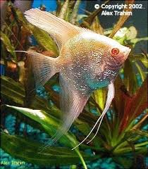

**Origin: Heavenly attendants are extraordinarily molded fish, and presumably consequently a standout amongst the most famous aquarium fish. Their precursors initially lived in the heart of the Amazon Rainforest in South America.**

**Behaviors: Most Angels are not active swimmers. They seem to prefer a more *relaxed lifestyle* than many other hyper-active fish. Angels are members of a big family of fish called Cichlids, and most Cichlids are aggressive, some are even very aggressive, but Angels are usually not too aggressive. Unless they are pairing off, spawning, or tending to their eggs or babies, then they are aggressive. A pair will work together to attack other fish that come too close.**

**Feeding: *Premium Fish Food Flakes* when small and *Premium Pellet Food* when larger.**

**Life Span: Angels live for *several years* and sometimes many years with proper care, good water, and premium food.**

Fish tank price=40

Fish for a 10-gallon Warm-Water Aquarium - Just Fish and Shrimps not the aquarium or decorations. F1

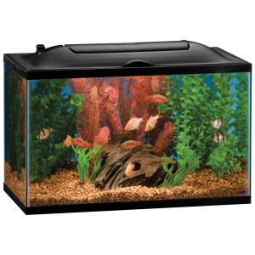

**This item contains** a group of compatible pet fish and shrimps that will live together nicely in a 10-gallon warm-water aquarium, so you'll need an aquarium heater.  You'll get ...

5 White Clouds   
5 Zebra Danios   
3 Ghost Glass Catfish   
5 Ghost Shrimp

1 Sample of Premium Flake Food   
1 Bag of Lava Rock

The aquarium and the decorations are not included. Just the fish, the shrimps, lava rocks, and a food sample.

**Fish for a 15-gallon Warm-Water =60**

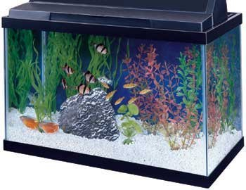

* The All-Glass standard size aquarium is made with care to assure that it can stand up to almost any application
* These aquariums come in a wide range of sizes as well as Black and Oak trim styles
* Large aquariums feature one-piece center-braced frames that eliminate glass Bowing

**Fish for a 20-gallon Warm-Water Aquarium price=75**

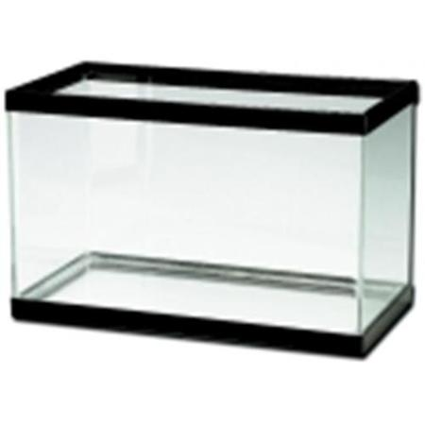

* The All-Glass standard size aquarium is made with care to assure that it can stand up to almost any application
* These aquariums come in a wide range of sizes as well as Black and Oak trim styles
* Large aquariums feature one-piece center-braced frames that eliminate glass Bowing

Xtreme Premium Flake Food, 1 oz. food 1price=12

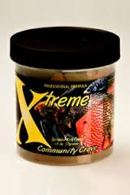

**There are** very few really good fish foods. We call them premium fish foods. Hikari makes many premium foods that are very good and available just about everywhere pet fish are sold. You should try Hikari foods. Xtreme also produces premium fish food, that are not as widely available, so we offer it for sale here as a service to our customers. 

Xtreme Premium Pellet Food, 5.6 oz. food 2 price=18



**There are** very few really good fish foods. We call them premium fish foods. Hikari makes many premium foods that are very good and available just about everywhere pet fish are sold. You should try Hikari foods. Extreme is also good, but not as widely available, so we offer it for sale here as a service to our customers.

AquaCleanse Tap Water Detoxifier for Freshwater, 2 oz. fish med 1 price=13

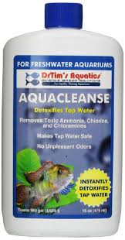

**Tapwater** contains chemicals that kill bacteria, viruses, and parasites, making tapwater safe for people to drink. AquaCleanse neutralizes these chemicals and makes tapwater safe for fish.

**First Defense Fish Stress Relief for Freshwater Aquaria, 2 oz. fish med 2 price=15**



**Many things** can cause fish to feel stressed. First Defense helps all kinds of fish to adapt to all kinds of stress by enhancing the fish's natural immune system.

**Waste-Away Sludge Busting Bacteria for Freshwater Aquaria, 2 oz. fish med 3 price=12**

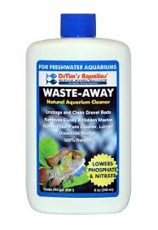

**Fish produce waste** that accumulates in the gravel, in the filter, and just about everywhere. Waste-Away contains natural beneficial microbes that digest fish waste and clean the aquarium. The beneficial microbes will not harm the fish or other aquarium inhabitants.

One & Only Nitrifying Bacteria for Freshwater Aquaria, 2 oz. fish med 4 price=11

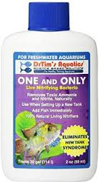

**Biological filtration** is the single most important factor in a successful aquarium. One and Only contains the beneficial bacteria that do the biological filtration and digest the fish waste.

**Denytrifying Lava Rocks, 8 oz. bag d1 price=10**

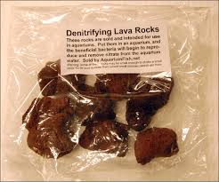

**Lava Rock** is a very important product for every freshwater aquarium. A rather small amount of aquarium-safe Lava Rock will keep the nitrates in the aquarium at just about the ideal concentration. Too much nitrate is not good, and too little is also not good.

REFRENCE

http://aquariumfish.net/home.htm#!/c/0/inview=category10828179&offset=0&sort=normal

**Premium Male Black Phantom Guppy b1 price=15**

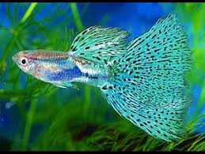

**Origin:** Guppies are a standout amongst the most beautiful and most prevalent aquarium fish. Their progenitors initially lived in Northeastern South America, however Guppies are currently found all through a large portion of the world.

**Behaviors:** Most male Guppies eat, chase female Guppies, and quarrel with other male Guppies. Guppies are ***not aggresssive*** to other fish.

**Life Span:** Guppies live for ***a few years***. In the meantime the next generation of Guppies have usually been born.

**Feeding: *Premium Fish Food Flakes***

**B2 Dalmatian Sailfin Molly Male price=17**

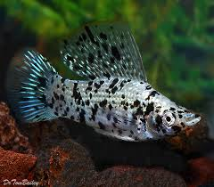

**Origin:** Mollys are a standout amongst the most vivid, and most well known aquarium fish.Their predecessors initially lived in seaside territories of southern Mexico in freshwater, harsh water, and saltwater. Yet, Mollys are presently discovered living in aquariums all through the vast majority of the world.

**Behaviors:** Most Mollys are ***very active swimmers***, and chase each other, but are rarely too aggressive.

**Feeding: *Premium Fish Food Flakes*** when small and ***Premium Pellet Food*** when larger.

**Life Span:** Mollys live for ***a few years***. In the meantime the next generation of Mollys have usually been born.

**Bubble-Eye Goldfish b3 price=14**

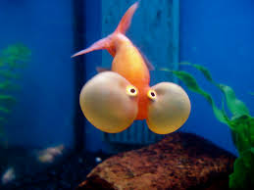

**Origin:** Goldfish are a standout amongst the most bright and most well known aquarium fish. Their predecessors initially lived in East Asia, however Goldfish are presently discovered living in aquariums all through the vast majority of the world. There are numerous shading assortments available to be purchased in this store.   
**Feeding: *Premium Fish Food Flakes*** when small and ***Premium Pellet Food*** when larger.

**Life Span:** Goldfish live for ***several years*** and perhaps even many years with good water and good food.

**Behaviors:** Most Goldfish are ***active swimmers*** and are ***rarely too aggressive***.

Guppy b4 price=11

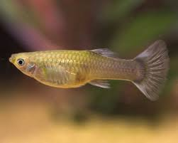

**Origin:** Guppies are one of the most colorful and most popular aquarium fish. Their ancestors originally lived in ***Northeastern South America***, but Guppies are now found throughout most of the world. There are many color varieties for sale in this store.

**Behaviors:** Most male Guppies eat, chase female Guppies, and quarrel with other male Guppies. Guppies are ***not aggresssive*** to other fish.

**Feeding: *Premium Fish Food Flakes***.

**Life Span:** Guppies live for ***a few years***. In the meantime the next generation of Guppies have usually been born.